Concepts in simple regression analysis
- The model
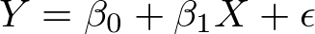

- Y is called response variable

- X is predictor variable

- 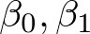 are unknown variables that we need to estimate

- 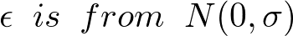 is a random noise, we do not know either, and also need to estimate it.

- Least square method to compute the best fit line

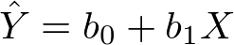

- 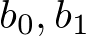 are the estimation of  , respectively.

- We also have a parameter, s, that estimates .

(There are formulas to compute these numbers, 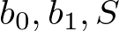, but we mostly use Minitab)
One formula to remember is

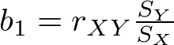

- Explained, Unexplained Variations, and coefficient of determination

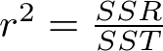

Interestingly, the value of r here is the same as in the formula above.

- Testing

We usually test the value of 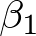 , for example,

But the most common test is

This test has special meaning: Is there a significant relationship between the predictor variable and the response variable.

We learn how to use Minitab to execute these tests.

- Confidence interval and Prediction Interval

Given a value of the predictor variable, we want to provide 95% or 99% confidence interval for the corresponding response variable.

There is a fundamental difference between the two kinds of intervals.

- Testing the error terms
Sometimes the linear model that we started in bullet 1 is not totally the right model. To check whether such a model is reasonable, we analyze residuals, which are the error terms: the differences of
